1)The ball must go up when we tilt the line upwards. Put the pieces of code together to do this.

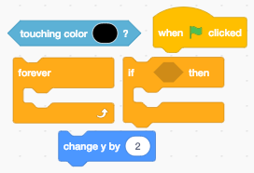

1)The ball must go up when we tilt the line upwards. Put the pieces of code together to do this.



2)The ball must go down, so it touches the line.

Put the pieces of code together to do this.

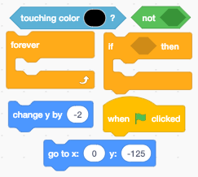

2)The ball must go down, so it touches the line.

Put the pieces of code together to do this.



3)We must now figure out what to do if the ball hits the grey and green shapes.

4)If we touch the grey shape we lose.

5) If we touch the green shape we win. touch

Put the pieces of code together to do this.

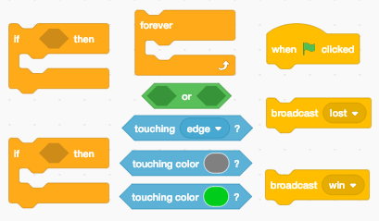

3)We must now figure out what to do if the ball hits the grey and green shapes.

4)If we touch the grey shape we lose.

5) If we touch the green shape we win. touch

Put the pieces of code together to do this.

